Part 1 SAT Research relevant to specifications in the design brief
After writing your design brief you will need to ask yourself the following question: What information do you need to know about your theme or idea to help guide your food ideas and final selection?
This information must be directly related to the specifications in the design brief and should be approximately one to two A4 pages of writing. You will need to use a range of primary and secondary sources and should include 5 different types of research
- Look at your specifications of your brief to determine what you are going to research. This makes sure the research is relevant
- Set up a bibliography now to manage your resources and to be ready to cite your references.
- Make sure you have included both primary and secondary resources
The following are examples of primary and secondary sources of research:
Primary research involves gaining first-hand information such as:
- Visiting a supermarket or fresh food market to observe particular varieties of produce
- Interviewing a grower at a farmer’s market
- Interviewing a person with expert food knowledge
- A visit to a restaurant to sample new foods.
Secondary research involves accessing published information from:
- Books
- Magazines
- Websites
You must use APA citing references of all of the resources you have used to gather this information. Remember to write the information from your secondary research in your own words and do not include downloads or screen dumps from website
The following are examples of possible areas for research.
Key ingredient:
- varieties/types of the key food/ingredient available
- natural components of the key food/ingredient
- functional properties
- seasonal availability
- ways in which the key food/ingredient can be purchased
- the most suitable cooking techniques to use when preparing this key food/ingredient.
A sporting event for example, a dinner for Casey Stoner’s pit crew at the Philip Island Motor GP:
- Casey Stoner and his food philosophy or favourite foods
- time of the year the event is to be held
- style of the dinner service for example, a sit down three-course dinner or finger food or shared plates
- menus suitable to be served
- types of foods suitable to serve at the dinner
- natural components of the key food/ingredient
- creative ideas for presentation.
A favourite film or book:
- the way in which the theme relates to the film or book
- identification of the foods used in the story or film
- the characteristics of the main characters and links to foods
- creative presentation of foods identified.
A celebrity such as a fashion designer, scientist, artist, musician or movie star:
- favourite foods
- food in relation to their work
- their personal life style
- what they cook at home or what is in their fridge or shopping trolley
- favourite restaurant or dining experience
- natural components of the key food/ingredient.

Task
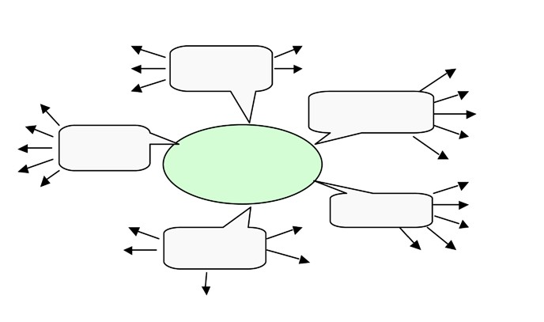
Regional Victorian produce for a region such as the Yarra Valley, Mornington Peninsula, Geelong region, Gippsland, Daylesford or Sunraysia:
- foods grown in the particular area
- secondary production of food in the area
- farmer’s markets in the area
- cafes restaurant that include local produce in their area.

Part 2 Research of possible ideas for food items
Prepare a diagram to outline useful information about components or characteristics of the food items that will guide your recipe search and meet the needs of the design brief. You should include 4 or 5 ideas for each food item. This is not a recipe search but a way of documenting some of your thought processes after you have started your research. This may be a simple, hand-drawn mind map to capture your initial thoughts or it can be produced using a software package such as Inspiration or Mindmanager. Include the specifications of your brief in the mind-map to make sure it is all relevant to your brief

Food item

Food item

Food item
Design

Food item

Food item
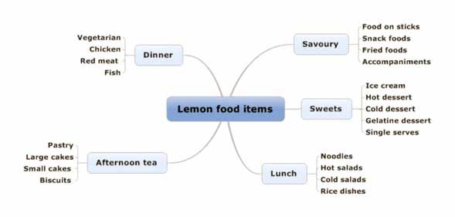

Now you must research possible recipe ideas based on the information in your mind map. You will need to have at least three (3) possible ideas for each food item that must also meet the specifications in the design brief. Your selection of the food items MUST be creative and of a Year 12 standard

