Water management strategies

Complete the concept map to outline key management strategies to reduce water use in food production.

Reclaimed water

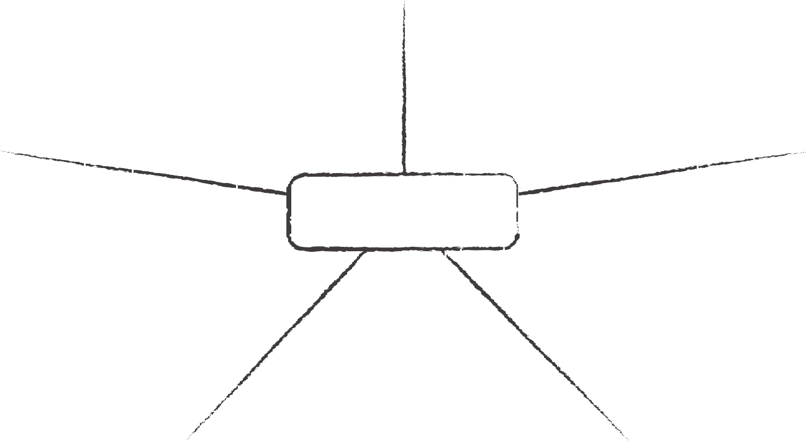

**Genetically modified seeds**

**Rainwater**

**Strategies for sustainable water use**

**Drip irrigation**

**Worksheet**

**Reduce evaporation**