TASK 1 Complete the activity using the sheets provided on the quantitative and qualitative tests on rice crackers.
TASK 2
Compare these 2 brands of commercial custard.
- What is viscosity and why is it important in a product such as custard?
- Is this a qualitative or quantitative test?
- Use the concentric circles below and sit it under a sheet of baking paper to test the viscosity of the 2 brands of readymade custard.
- Measure out exactly the same (1 level tsp) and put into the centre circle. Note the differences in a 1 minute time period.
- Which one has a greater viscosity? What implications does this test have when testing a new custard product?

Name of brand 2 custard
Name of brand 1 custard

TASK 4
Use a hedonic scale to compare each type of milk
Milk 1 __________________________
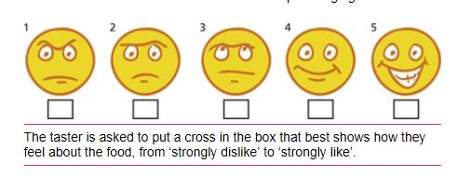
Milk 2 __________________________
Milk 3 _____________________________

Do a quick PMI about this type of product testing. Use your textbook p246
Interesting
Negatives
Positives

TASK 5
Now heat ¼ cup of each type of milk. Use the 9 point likening hedonic scale below to record taste test results. Do you notice anything interesting?

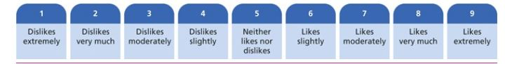
TASK 6
Find out what is meant by the term ‘Functional Foods’ and explain it below in your own words. Give an example of 4 different functional foods and explain why they are becoming more prevalent (in demand) *** Add to your unit4 glossary, see weebly
__________________________________________________________________________________________________________________________________________________________________________________________________________________________________________________________________________________________________________________________________________________________________________________________________________________________________________________________________________________________________________
TASK 5
Use the link on the weebly on a profiling test star diagram. Copy this and make one for your first food item

Find out what microencapsulation is and how it is used in new emerging technologies in food product design. Give 2 examples of products where this is used and explain why it is important in these products ****Add to your unit 4 glossary, see weebly
_______________________________________________________________________________________________________________________________________________________________________________________________________________________________________________________________________________________________________________________________________________________________________________________________________________________________________________________________________________________________________________________________________________________________________________________________________
Milk 3
Milk 2
Milk 1

