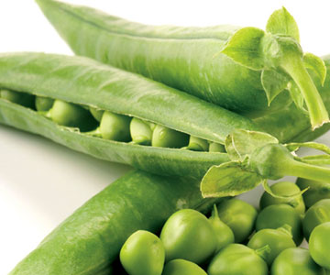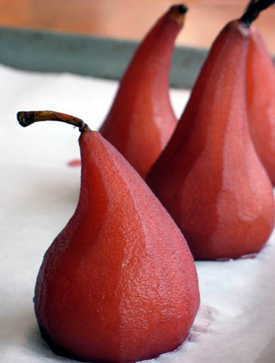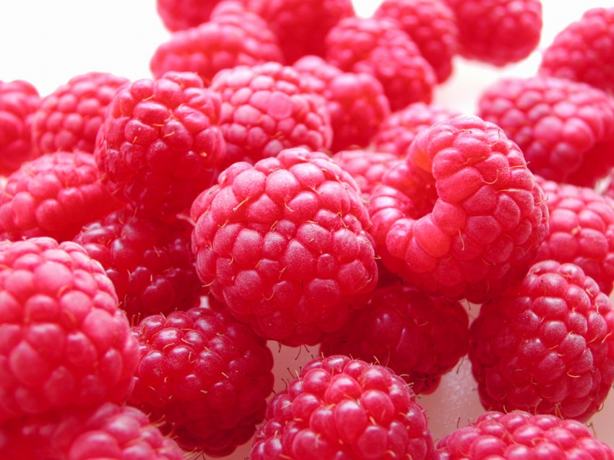

Transition Program 2016

Name ___________________________

**Food & Technology**

**Year 12**

Food & Technology 2016

# Text

# Heath, McKenzie &Tully, (2010) *Food Solutions Units 3 & 4 Food & Technology,* Pearson Education

#### 

# Assessment

A variety of different methods will be used to assess your knowledge, including:

* Tests (short and/or extended answer)
* Structured questions
* Short written reports
* Case studies
* School Assessed Task (SAT)
* Exam

# SACs

* Unit 3 SACs: 18% /20 /40
* Unit 4 SACs: 12% /40
* School Assessed Task 40% /45
* End-of-year examination: 30%
* Most of the SACs will be closed book and require responses to detailed short answer questions
* Sometimes stimulus material or a case study is provided prior to the SAC. SACs may be prepared for by following the ‘SAC preparation sheet’, which will provide brief outlines of the content that is assessable.

# Examination

The exam in November is 90 minutes long (100 marks) and consists of MCQ’s, short answer questions and one extended response testing Units 3 & 4.

# VCAA detailed information

The study design can be found on this page:

<http://www.vcaa.vic.edu.au/vce/studies/foodtech/foodtechindex.html>

**Tips for success in**

**Food & Technology**

1. Attendance- if you miss class, it is your responsibility to catch up on work
2. Be organised- have a folder organised into Areas of Study (two for Unit 3 and one for Unit 4)
3. Complete all work requirements- come into class prepared to work
4. Seek feedback- particularly on folio work, complete all practice SAC questions
5. Your teacher is your best resource- meet regularly with teacher during own time or organise to come as a small group
6. Detail- the students who do well go beyond the basic detail and use terminology with confidence
7. Start planning now for SAT- begin thinking of themes, collecting recipes and pictures
8. Practice- when it comes to folio products, practice your food items at home- remember you will be assessed on your skills demonstrated in class
9. Revise from the beginning- make your life easy when it comes to exam time. Maintain a working glossary, do AOS (SAC) summaries, use revision tools such as summary tables, flow charts and concept maps



Consistency throughout the year is the key to success in any subject!

Slow and steady wins the race!

**Work to complete…**

**HOLIDAY HOMEWORK**

**Instructions**

* *This work is to be submitted the first day in term 1 that you have F&T.*
* *Late submission of work is not a good start to the year*
* *Several of these exercises require research and overall this task is quite time consuming, so allow plenty of time to get it done to the very best of your ability.*
* *Try to complete it within the last 2 weeks of the holidays before returning to school as it will then be still fresh in your mind - easier to remember.*

|  |  |  |  |
| --- | --- | --- | --- |
| **Topic** | **Work to complete** | **Text pages** | **Done √** |
| Read all of **Chapter 1 ‘Food poisoning and food spoilage’** before you start the following: | 1. Complete ‘*Understanding the text’* questions 1-10 | 5 |  |
| 1. Visit the FSANZ website for food safety standards for food businesses   <http://www.foodstandards.gov.au/industry/safetystandards/Pages/default.aspx>  Why are these important to have? Briefly explain what a ‘food safety program’ is. Make a list of the sort of things that a business is required to do in a food safety program. |  |  |
| 1. Read worksheet *‘Types of food poisoning’*. Answer the following: 2. Can you relate to any of these types of food poisoning? If so, which type? 3. What type of food do you think it was that caused the food poisoning? |  |  |
| 1. Read & complete worksheet *‘Food poisoning chain of events’* |  |  |
| 1. Complete *Activity 1.1 ‘Food spoilage and poisoning’* | 6 |  |
| 1. Complete *Activity 1.2 ‘Causes of food-borne illness in Australia’* | 10 |  |
| 1. Complete *‘Understanding the text’* questions 11-20 | 10 |  |
| 1. Complete the quiz at <http://www.betterhealth.vic.gov.au/bhcv2/bhcarticles.nsf/pages/Quiz_food_safety?open> |  |  |

|  |  |  |  |
| --- | --- | --- | --- |
| Read all of **Chapter 2 ‘Maintaining food safety in Australia’** before you start the following: | 1. Complete *‘Understanding the text’* questions 1-10 | 16 |  |
| 1. FSANZ is responsible for the formulation of the Food Standards Code open this link   <http://www.foodstandards.gov.au/_srcfiles/Meat_0801.pdf>  Answer the following questions:   1. Explain the difference between manufactured meat and processed meat. 2. Outline the composition of a sausage. 3. From your search of this link, provide examples of the main roles of the food standards code; refer to p14-16 of your text when answering this question. |  |  |
| 1. Use this link to find out what is required on a food label and why it is included (select the different options in the scroll bar) <http://www.foodstandards.gov.au/foodmatters/foodlabelling/interactivelabelpost3614.cfm> |  |  |
| 1. Use the information from the link above to identify and justify the components of a food label for jam in the cupboard |  |  |
| 1. Complete *Activity 2.1 ‘Identifying potential critical control points in food processing’* | 23 |  |
| 1. Complete *‘Understanding the text’* questions 11-20 | 24 |  |
| 1. Complete *Activity 2.2 ‘Food product recall’* | 29 |  |
| 1. Complete *‘Understanding the text’* questions 21-30 | 30 |  |

**Understanding the text - Questions 1-10 (P. 5)**

1. ________________________________________________________________________________________________________________________________________________________________________________________________________________________________________________________________________________________
2. ______________________________________________________________________
3. __________________________________________________________________________________________________________________________________________________________________________________________________________________
4. ______________________________________________________________________________________________________________________________________________________________________________________________________________________________________________________________________________________________________________________________________________________________
5. The four main causes of food spoilage and food poisoning
6. ____________________________________________________________________________________________________________________________________________________________________________________________________________________________________________________________________________________________________________________________________________________________________________________________________________________________________
7. ______________________________________________________________________________________________________________________________________________________________________________________________________________________________________________________________________________________________________________________________________________________________
8. ____________________________________________________________________________________________________________________________________________________________________________________________________________________________________________________________________________________________________________________________________________________________________________________________________________________________________
9. ________________________________________________________________________________________________________________________________________________________________________________________________________________________________________________________________________________________
10. ____________________________________________________________________________________________________________________________________________________________________________________________________________________________________________________________________________________________________________________________________________________________________________________________________________________________________





**Read & complete worksheet *‘Types of food poisoning’***

1. Can you relate to any of these types of food poisoning? If so, which type?

____________________________________________________________________________________________________________________________________________

______________________________________________________________________

1. What type of food do you think it was that caused the food poisoning? __________________________________________________________________________________________________________________________________________________________________________________________________________________

**Read & complete worksheet *‘Food poisoning chain of events’***

1. ______________________________________________________________________________________________________________________________________________________________________________________________________________________________________________________________________________________________________________________________________________________________
2. ______________________________________________________________________________________________________________________________________________________________________________________________________________________________________________________________________________________________________________________________________________________________
3. ______________________________________________________________________________________________________________________________________________________________________________________________________________________________________________________________________________________________________________________________________________________________
4. ______________________________________________________________________________________________________________________________________________________________________________________________________________________________________________________________________________________________________________________________________________________________

**Activity 1.1 – *‘Food spoilage and poisoning’* (P. 6)**

**Complete the following table summarising food spoilage and food poisoning**

|  |  |
| --- | --- |
| **Food spoilage** | **Food poisoning** |
| Definition | Definition |
| Causes of food spoilage | Causes of food poisoning |
| Examples of foods that can spoilage | Examples of foods that can become contaminated with food-poisoning bacteria |

**Activity 1.2 – *‘Causes of food-borne illness in Australia’* (P. 10)**

1. __________________________________________________________________________________________________________________________________________________________________________________________________________________________________________________________________________________________________________________________________________________________________________________________________________________________________________________________________________________________________________
2. ____________________________________________________________________________________________________________________________________________________________________________________________________________________________________________________________________________________________________________________________________________________________________________________________________________________________________
3. ____________________________________________________________________________________________________________________________________________________________________________________________________________________________________________________________________________________________________________________________________________________________________________________________________________________________________
4. ____________________________________________________________________________________________________________________________________________________________________________________________________________________________________________________________________________________________________________________________________________________________________________________________________________________________________
5. ____________________________________________________________________________________________________________________________________________
6. ____________________________________________________________________________________________________________________________________________

**Understanding the text - Questions 11-20 (P. 10)**

1. __________________________________________________________________________________________________________________________________________________________________________________________________________________________________________________________________________________________________________________________________________________________________________________________________________________________________________________________________________________________________________
2. ________________________________________________________________________________________________________________________________________________________________________________________________________________________________________________________________________________________
3. ____________________________________________________________________________________________________________________________________________________________________________________________________________________________________________________________________________________________________________________________________________________________________________________________________________________________________
4. ____________________________________________________________________________________________________________________________________________________________________________________________________________________________________________________________________________________________________________________________________________________________________________________________________________________________________
5. ________________________________________________________________________________________________________________________________________________________________________________________________________________________________________________________________________________________
6. __________________________________________________________________________________________________________________________________________________________________________________________________________________________________________________________________________________________________________________________________________________________________________________________________________________________________________________________________________________________________________
7. ______________________________________________________________________________________________________________________________________________________________________________________________________________________________________________________________________________________________________________________________________________________________

Main safe food handling practices

1. __________________________________________________________________________________________________________________________________________________________________________________________________________________
2. __________________________________________________________________________________________________________________________________________________________________________________________________________________